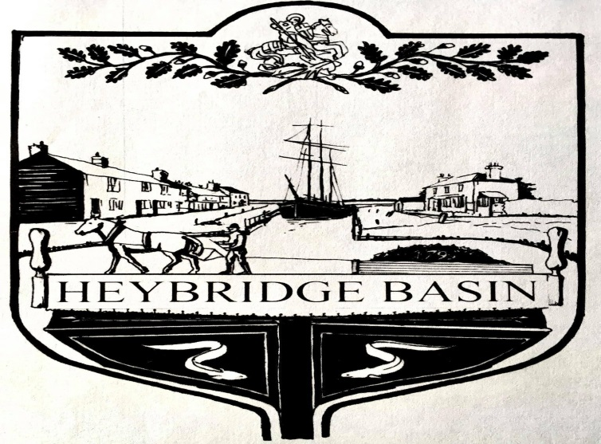

**Heybridge Basin Parish Council**

**Application to South Essex Parking Partnership**

**Requesting a change in parking restrictions**

**July 2024**

Contents

1. Application Form
2. Appendices
   1. Background statement and Timeline
   2. Support from Essex County Council local area Councillor and local Maldon District Councillors.
   3. Maps and Pictures
   4. Findings from Residents Survey of households directly affected.
   5. Notes from a meeting of the Heybridge Basin Parish Council’s On Street Parking Working Group 24th May 2023.
   6. Notes from a meeting of the Heybridge Basin Parish Council’s On Street Parking Working Group 23rd February 2023.
   7. Briefing notes provided to residents attending open village meetings 20th and 21st February 2023 including the findings of the whole village household survey October 2022.
   8. Residents Survey of all households in Heybridge Basin October 2022.

**2.1 Background Statement and Timeline**

Heybridge Basin Parish Council (HBPC) has been considering the On Street parking situation within the village since 2021. The existing On Street parking regulations have been in place for decades and over time the volume of visitors has increased dramatically following increased house building in the Maldon District, promotion of Heybridge Basin as a tourist destination by Maldon District Council, recreational users of the canal increasing and increased visitors during COVID.

In 2022, after a period of consultation with residents, HBPC introduced charges to park in Daisy Meadow Car Park within the village. The car par has 117 bays, including 5 Blue Badge bays, plus 11 bays for residents without off street parking provision. (Note: any household in the parish is able to have up to 2 parking spaces either free or at a heavily discounted annual rate and staff of businesses in the parish also have discounted rates).

As part of this consultation process residents expressed concerns that the introduction of charging in Daisy Meadow would increase the amount of on street parking as visitors sought to avoid charges. HBPC therefore agreed to conduct a review of the regulations in the light of experience once the charges had been introduced.

What has actually happened is that Daisy Meadow very often is full to capacity, at all times of the year, and vehicles overspill onto the streets.

In October 2022 HBPC conducted a survey of the 271 households in the parish to establish resident’s views on the on street parking situation. Some 61 responses were returned with a wide range of opinions and suggestions for change. See 2.7 and 2.8.

Following the survey HBPC held two open village meetings in February 2023 to present the findings and to collect further reactions. The meetings were well attended, 62 residents, many of whom had not completed the survey.

HBPC’s On Street Parking Working Group then met on several occasions to discuss the findings and to distil them into a working proposal. See 2.6 and 2.7. The Working Group’s suggestions were put to the full Parish Council and it was agreed to proceed with an application to SEPP. See PC meeting minutes July 2023, item 23/26.

The next step was to conduct a petition of the 36 households directly affected by the proposed changes. The first round in October 2023 did not generate enough responses and so a second round, house by house, was undertaken in May 2024. This exercise increased the response rate to 74% - those not responding are mainly from houseboat owners or rented properties. Of responders 21 or 60% of the total households affected were supportive of the changes. See 2.3 and 2.4.

Both our local Essex County Councillor, Mark Durham and our Maldon District Councillors, Nick Spenseley and Nikki Swindle support the application. See 2.2